**EXERCISE 5: SQL SUBQUERIES**

**Name- Anas Jawed**

Consider the database for an organization and create the following tables.

* **DEPARTMENT** (dept_no, dept_name, location).
* 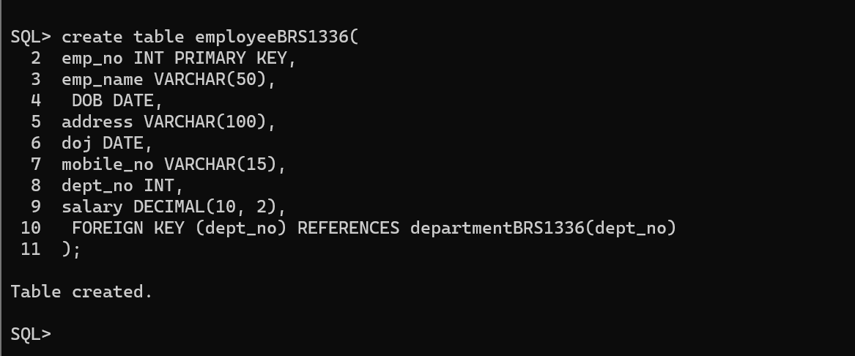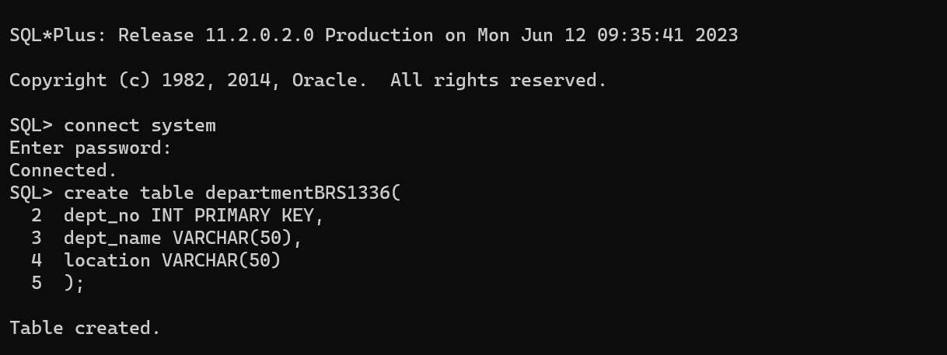**EMPLOYEE** (emp_no,emp_name,DOB, address, doj, mobile_no, dept_no, salary).

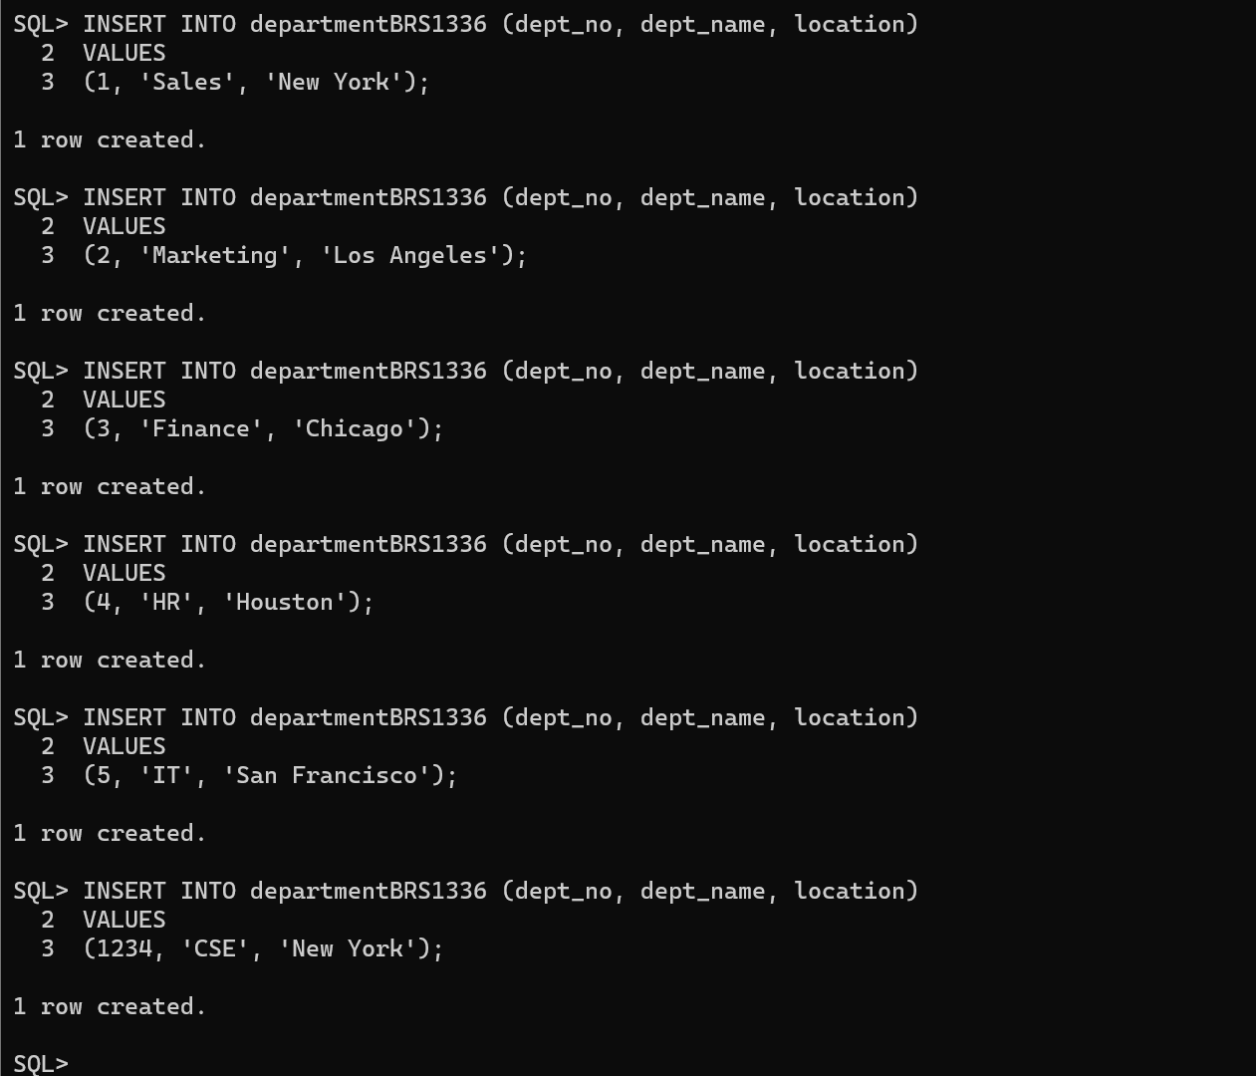

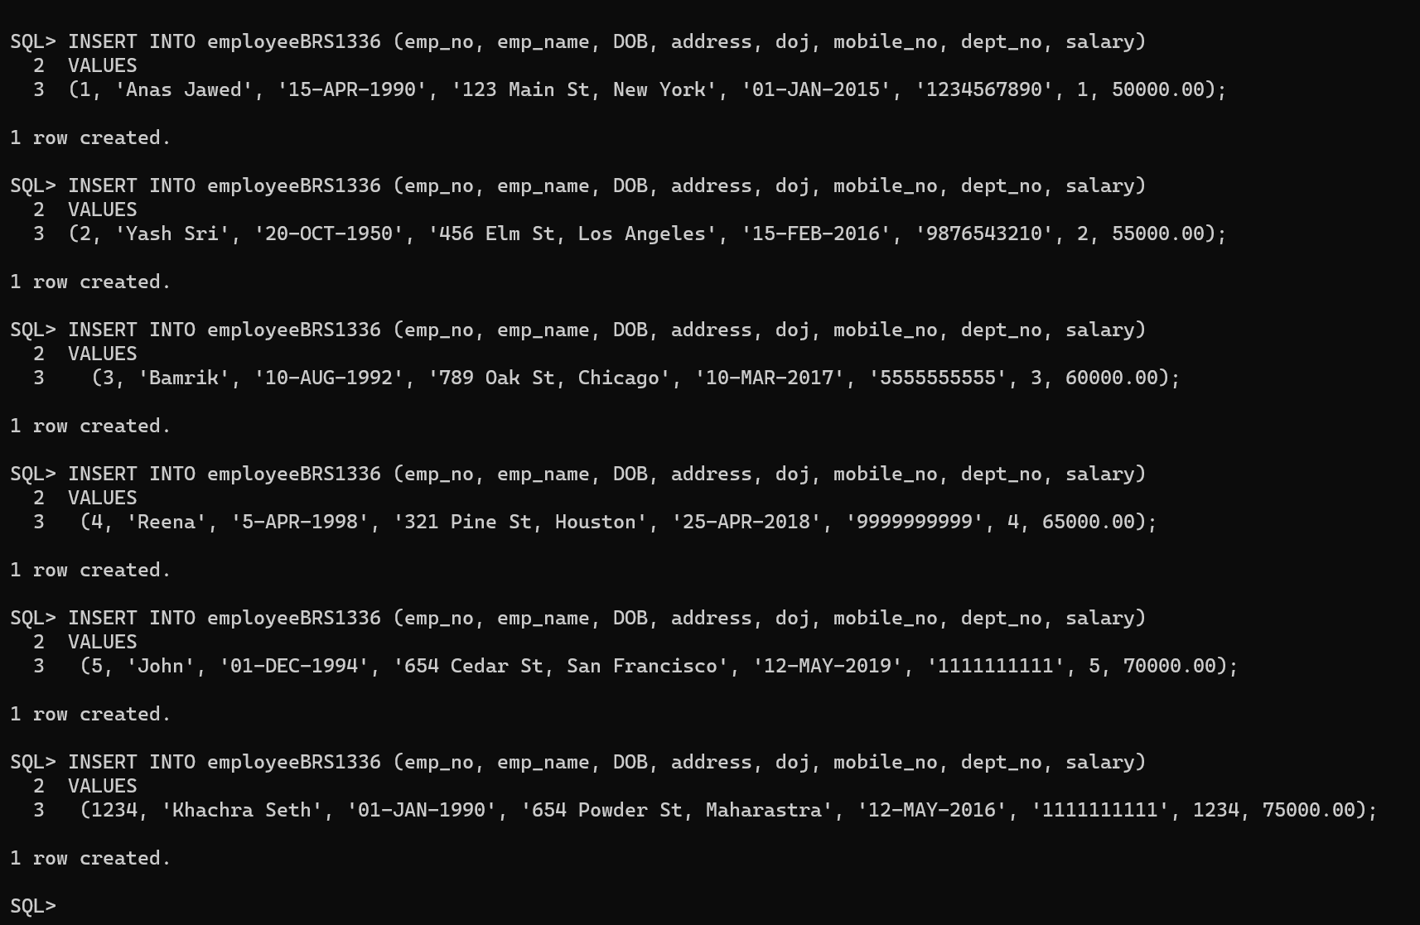



**Write queries for solving the following:**

1. 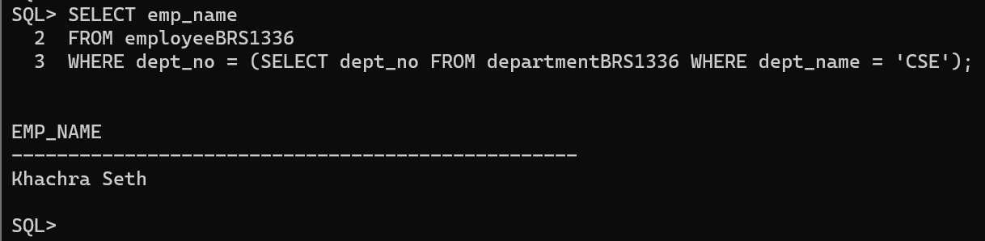Display the names of the employees working for CSE department
2. 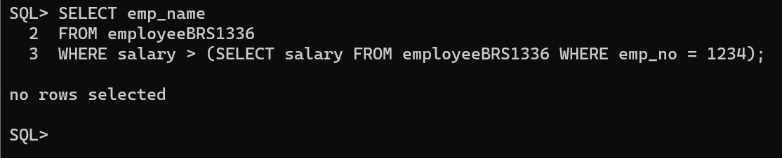Display names of employees whose salary is greater than the employee emp_no=1234
3. Display all the employees drawing more than or equal to the average salary of department number 5.

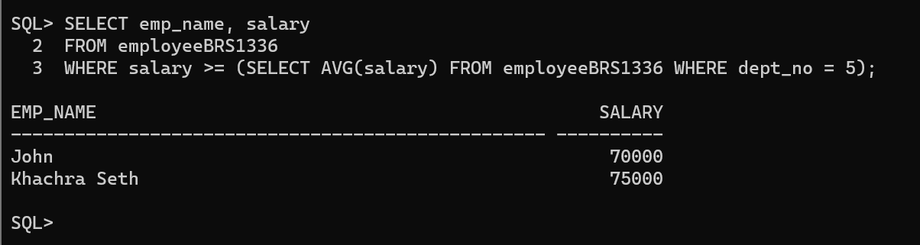

1. Display the name of the highest paid employee.

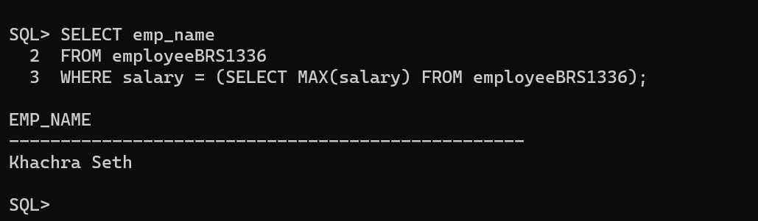

1. Find the Name and Salary of people who draw in the range Rs. 20,000 to Rs. 40,000.



1. Update the salary by 0.25 times for all employees who work in ~~research~~ HR department.

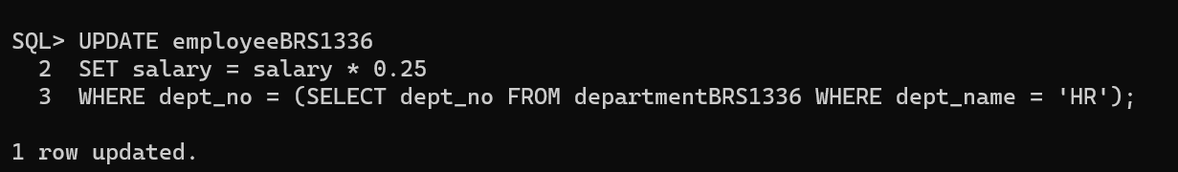



1. Delete all the employee details from admin department.

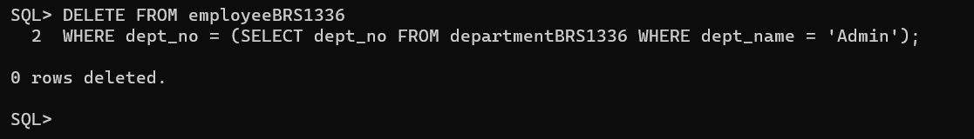

1. Display the department name in which employee that has lowest salary.

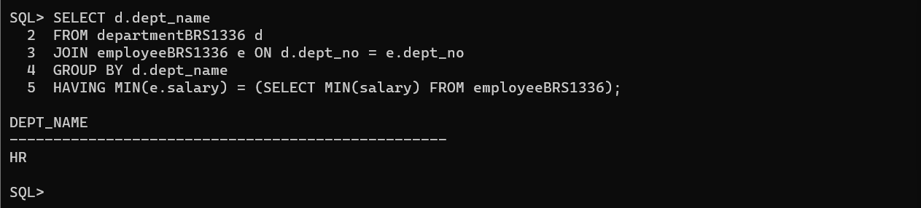

1. Display the employee details of all employees who earn more than that of ‘Reena’ and in the same department as ‘John’

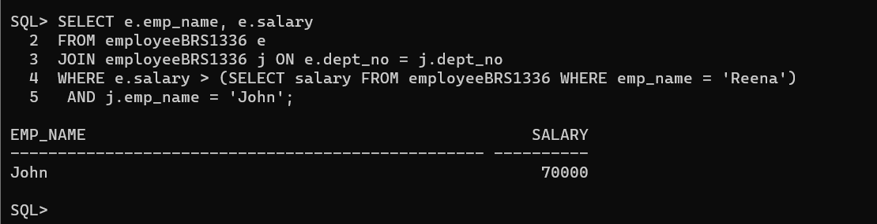

1. Display the name of the employees whose salary is less than the average salary of CSE department.

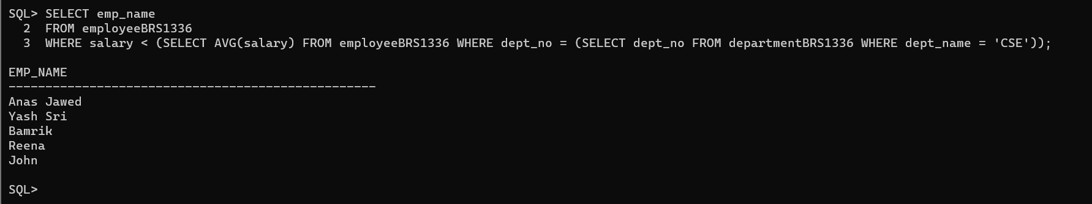

1. Count the number of employees of department where “John” works

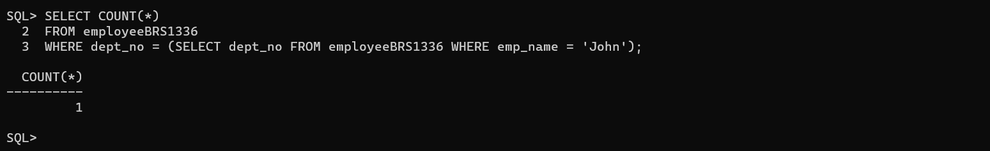

1. Get Department number and name from department table and employee no and name from employee table, after a CROSS JOINING





----------------------------------------END----------------------------------------------